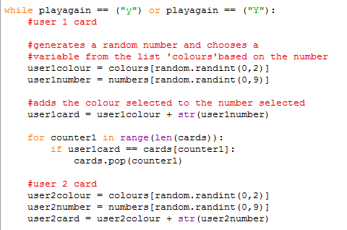

I realised that since I had already shuffled the list, I don’t need to use a random number

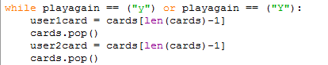

Much simpler!